A BRIEF GUIDE TO HISTORY AND ATTRACTIONS IN NIZHNY NOVGOROD.
A non-obligatory reading before the Nizhny Novgorod trip for those who interested not in science only; with recommendations what to visit in the old town in time free of sessions
Nizhny Novgorod in early Middle Ages was the East Outpost of the Moscow Princedom protecting the borders from raids of nomads, mainly from Kazan Khanate and Ugorian tribes. The Old Town Citadel, Kremlin (it means Fortress with Towers) was founded before the Mongolian Invasion to Ancient Russia (Rus, 1221) by Prince Yury Vsevolodovich, the Lord of Vladimir Principality. At foundation the Kremlin was build combining oak wood and some kind of cement. In the first period of the Russian independence from the Mongolian Empire with ruling of Great Prince Ivan The Third and later Vasily The Third (farther of Ivan the Terrible) (1500-1515), the Kremlin was rebuilt as the stone fortress by the Italian architect Fryazin (Pietro Franchesco), the one of the outstanding brothers, constructed earlier the white-stone Moscow Kremlin (1485-1495). The Kremlin protected the town and the Princedom borders for a long time, survived four raids of Kazan Khanate (1505-1552). After the Kazan conquest by Ivan The Fourth (Ivan The Terrible, 1552) the outpost role of the Kremlin was lost, and the fortress started to be the residence of the Nizhny Novgorod landlords. Originally the Kremlin had 13 towers, from which now available only 12. The Kremlin is situated on a Town Hill exactly in place where two great Russian rivers are joined: Volga and Oka (remember that Oka is a name of your hotel!). The Kremlin function now is a combination of Museum complex for tourist and the city government residence.
Kremlin contacts: +7 (831) 422 10 80, +7 (831) 422 10 81, square PLOSCHAD MININA I POZHARSKOGO, at the end of the historical road, now the street Bolshaya Pokrovskaya.
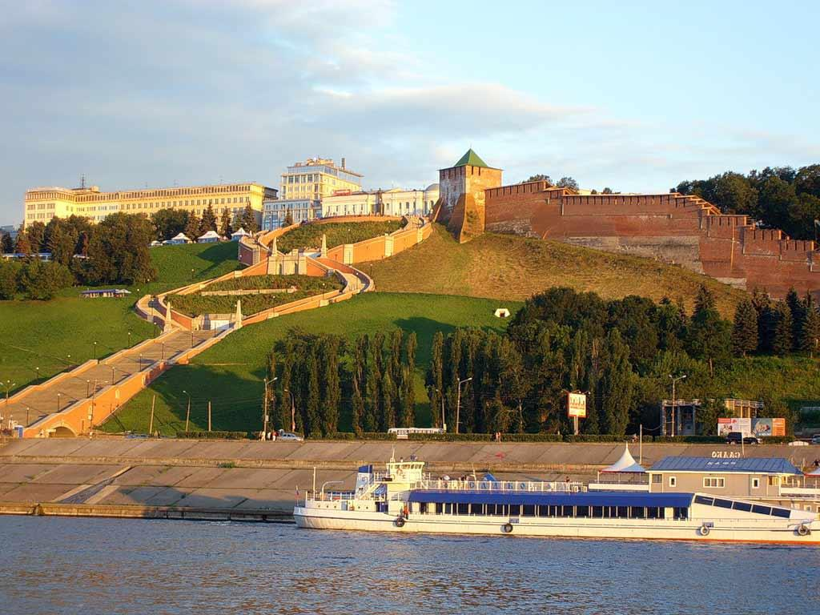
The Kremlin of Nizhny Novgorod. Photo: http://soc-life.ru/action/28118/
The free thinking is a typical feature of the citizens of Nizhny Novgorod, originated from the tradesmen pushfulness and the culture of opposition. It may be traced from the “Time of Troubles” after the death of Ivan the Terrible, from the opposition to the Central Orthodox Church (“staroobryadcherstvo” , Old Ritualists) until the main opposition leader of the modern Russia, Boris Nemtsov.
The Time of Troubles (1598-1613). The power vacuum after the death of Ivan the Terrible was caused by the absence of the throne male descendant of the Ryurik Dynasty. This situation was used by the Polish lords for the military invasion based on the old special Treaty between dynasties of both countries. During the Polish intervention accompanied by the robberies and incredible cruelties, the struggle between the political groups of Russian boyar tribes (landlords) took place, with numerous coalitions of boyars with Polish interventionists and armies of the field hitmans. Several short-time tsars changed each other, absence of effective ruling led to the chaos, hunger, plague epidemics. All roads were controlled by the local robber gangs, churches were plundered, every political party of boyars elected its own throne candidate the church leader (Patriarch). The salvation of the state came from the Nizhny Novgorod self-organizing community, because only this richest trade city was not involved in the war and robberies in the whole country. The butcher and tradesman Kuzma Minin and the army Commander Prince Dmitry Pozharsky had formed the People Militia movement which did the military ride to Moscow, expelled foreign interventionists and ensured the election at the Church Assembly (Zemsky Sobor, 1613) the Tsar of the new Romanov Dynasty, Mikhail Romanov. At the same Assembly the new church leader, Patriarch (father of Mikhail Romanov) was elected. The monuments of Minin and Pozharsky are situated in the center of the Kremlin in Nizhny Novgorod, and in the Red Square in Moscow.
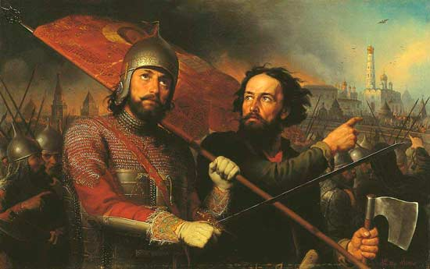
Prince Pozharsky and tradesman Minin. Artist: Scotti, 1850. Photo: http://rushist.com/index.php/russia/2289-pozharskij-dmitrij-kratkaya-biografiya

The Old Ritualists (Old Believers) movement in the Russian Orthodox Church. The conflict between the official church and the conservators was arisen in 17 century, during the ruling of Alexei, son of Mikhail (the first Romanov) and the father of Peter the Great. The sense of conflict was the revision of the church rituals done by the leader of the official church, the Patriarch Nikon. Nikon’s opponent, the Protopop Avvakum was a leader of mass opposition to the church reforms. Both leaders were originated from Nizhny Novgorod region, from the two neighbor villages. Most prominent difference was in the Sign of the Cross, the ritual blessing which it three-fingers in the official blessing and two-fingers in the old ritual. There were numerous additional differences in rituals, e.g. the direction of the Church Processions relating the Sun position in the sky, etc. As a consequence of the conflict the Old Ritualists were repressed and even burnt in their wooden prayer houses; they fled to deep forests and founded settlements (“skits”) located mainly along the river Kerzhenets in the Nizhny Novgorod region, and in the surroundings of the Svetloyar Lake. The Escape and the punitive expeditions were accompanied by mass suicides and immolations, as well as drownings of the Old Believers. The opposition leader, Protopop Avvakum “was burnt in wood blockhouse” according to the official church judgment . The Nizny Novgorod Region started to be the center of the Old Ritualists movement. Recently more than 100 ths Old Ritualists still populated the region and they held their assemblies annually at the coasts of the Svetloyar Lake where they read the holly text including the Legend of the Kitezh Town which floated down to the lake bottom thus saving the Old Believers and their Monks and properties.
Lake Svetloyar . Photo: http://rpsc-nn.ru/nizhegorodskoe-staroobryadchestvo/82-istoriya-nizhegorodskogo-staroobryadchestva.html 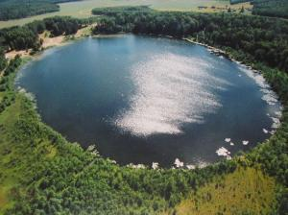 | 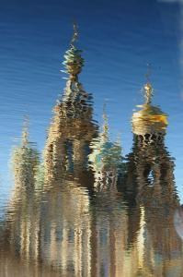 Kitezh town sinking down in the lake.

Skits (Old Ritualists settlements) were the nuclei of different rebellions against the central Power, among the rebellions the most famous are the raids of Kazaks: Stepan Razin, Emelyan Pugachev and Bolotnikov. Skits also were the refuges for the participants of the suppressed rebellions. Skits had their economic support from the Nizhny Novgorod Fair (old name — Makaryev Fair) which was a fair in Nizhny Novgorod held annually every July near Makaryev Monastery on the left bank of the Volga River from the mid-16th century to 1816. Old Ritualists were commercially active people; they have the intensive trade along the water pathways, rivers Volga and Oka. Their traditionally large families and numerous tribes allowed to accumulate rich capitals and thus they may develop trade and industrial enterprises, the largest in Russia.
The stable opposition of Old Believers caused the reaction of central government in Moscow. As the state persecutor the Archbishop Pitirim was appointed. He destroyed skits and tried to persuade Old Ritualists to the official church (1716-1719). Remarkable fact, that Pitirim himself was originally an Old Ritualist. He blamed his former fellows in greed and extremal cruelties. The second outstanding former Old Believer who transformed into the official church hierarch, was the famous writer Pavel Melnikov-Pechesky (1818-1883). He knew well the Old Ritualists ideology and life style from the inside. Starting as an Tsar official and persecutor, later he proposed the soft measures against sectarians, “for Co-religion”. Each skit had the holly fetish, the famous icon. As the police official (in a status of “ispravnik” which is analogous to sheriff) he transferred icons from skits into main official church buildings. Simultaneously he ensured the special quotes in the schools and universities for young Old Ritualists. Another his initiative was the transfer of the former Makaryev Monastery Fair into the city Nizhny Novgorod, thus replacing the religious fanaticism with commercial activities for Old Ritualists. Later Pechersky was the very famous writer of novels about lifestyle and traditions of Old Believers.
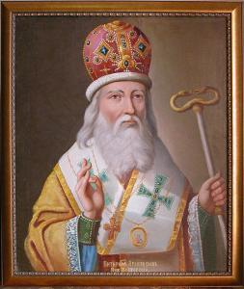 | 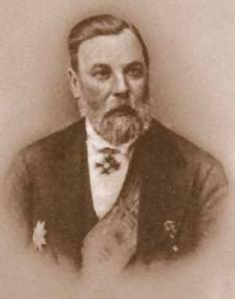
Archibishop Pitirim | Writer Melnikov-Pechersky
Photo: http://rpsc-nn.ru/nizhegorodskoe-staroobryadchestvo/82-istoriya-nizhegorodskogo-staroobryadchestva.html

Excursions to Sveloyar Lake from Nizhny Novgorod: http://www.klubok-ok.ru/Tury/Svetloyar.html
Citizens of Nizhny Novgorod are very creative and skillful. One of them, Ivan Kulibin (1735-1818), was named “Archimedes of Nizhny Novgorod”. He developed such construction as a ship which may move against the river Volga stream without an engine. Unfortunately his inventions were considered as the “things aimed just for fun” and therefore they were produced only in one copy. Later he was appointed as the Head of the Mechanic manufacture of the Academy of Science in St Petersburg, where he could revive the famous singing clock “Pavlin” (Peacock) originally constructed by James Cox and stored in the Hermitage as a set of details for 80 years. To that time many details were lost, and Mr Kulibin himself manufactured the missing things. Now the Peacock singing Golden Clock is one of the main Exhibits of the State Hermitage Museum in Saint Petersburg.

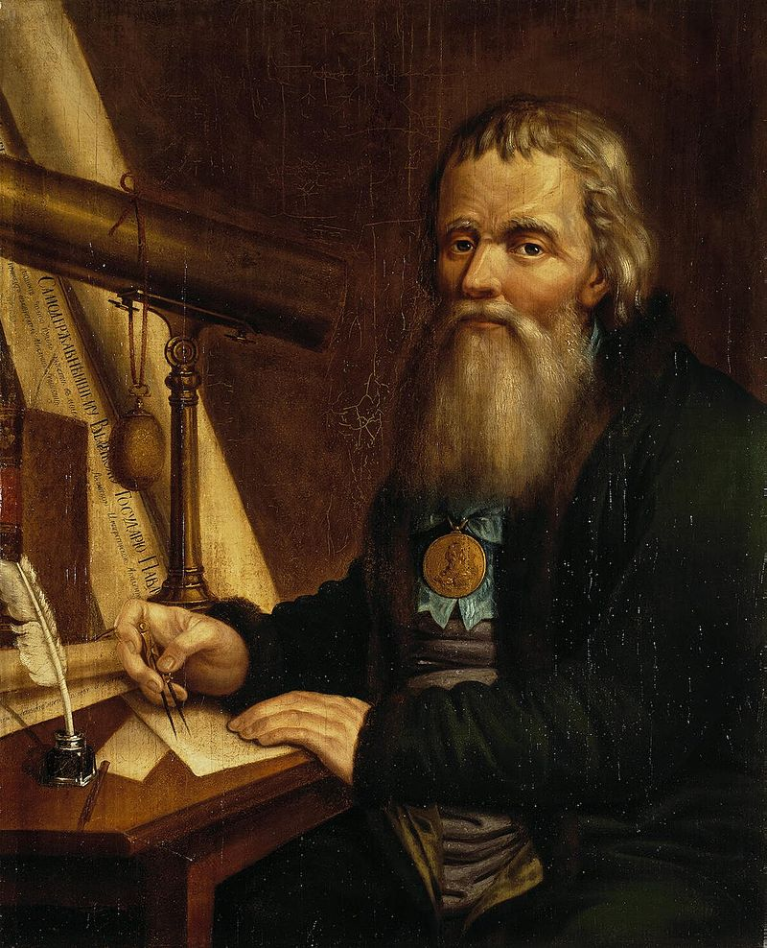
Ivan Kulibin. Artist: Vedenetsky. The State Hermitage. Photo: https://ru.wikipedia.org/wiki/%D0%9A%D1%83%D0%BB%D0%B8%D0%B1%D0%B8%D0%BD,_%D0%98%D0%B2%D0%B0%D0%BD_%D0%9F%D0%B5%D1%82%D1%80%D0%BE%D0%B2%D0%B8%D1%87

Other outstanding intellectual of the city was Nicolai Lobachevsky (1792-1856), The main University of the city (and the Symposium venue) is named after him. Lobachevsky was great mathematician and the developer of the non-Euclidean Lobachevsky geometry. He was born in Nizny Novgorod but his scientific career he made in the University of Kazan, where he worked for 40 years, during 19 years he was the rector of this University. Under his smart leadership the Kazan University was developed into one of the main universities of Russia. Hi was named as the “University Builder” and “Copernicus of Geometry”, the latter name had its sense while father of Nicolai has Polish origin (however taking no part in the son’s upbringing). The Nicolai’s interest in mathematics was risen by teacher Kartashevsky in the Kazan Gymnasium. Remarkably that already working at the Kazan University Lobachevsky was in conflict with the descendant of other great mathematician Leonty Magnitsky. The religious Magnitsky descendant was the State Sponsor of the university; he struggled for the substitution of science with religion and later was convicted of embezzlement of the state funds aimed for the univeristy.
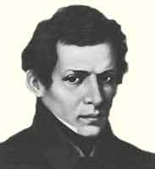 | Nicolai Lobachevsky. Photo: http://to-name.ru/biography/nikolaj-lobachevskij.htm
We advise to visit the Lobachevsky Museum in The Nizhny Novgorod State University (http://www.museum.unn.ru/managfs/index.phtml) and the University Botanical Garden with the unique live Collection of Orchids (http://www.unn.ru/botanicus/now01.htm; address: street Botanichesky Sad, 1. Tel.:8 (831) 465-51-41) .
In the USSR period the city of Nizhny Novgorod was re-named after famous writer Maxim Gorky (a pseudonym, the real name Alexai Maximovich Peshkov, 1868-1936) who was born in the city. Gorky has no regular education in in an official school, only learning the reading and writing with church books under home teaching of his grandfather who was bankrupted tradesmen. People named the teenager “the book swallower” for his passion of reading and self-education. Special role in Maxim’s upbringing played another great Russian writer Korolenko; the latter was of Ukranian origin but writes only in Russian and spent his main “creative decade” (1885—1895) in Nizhny Novgorod after his exile in Siberian Province Yakutia (now Autonomous Republic Yakutia in Russian Federation). Maxim Gorky is world famous writer. As the person originated from the poorest social groups (barefoots), he dreamed about the future new humans with clean spirit. From his literature work honoraria he sponsored firstly the socialist – “God-Builders” (Lunacharsky and Bogdanov) and later the Party of Vladimir Lenin. He went to the Bolshevism views under influence of his girl-friend (civil wife), the famous actress Andreeva, who was a member of Lenin’s Party.
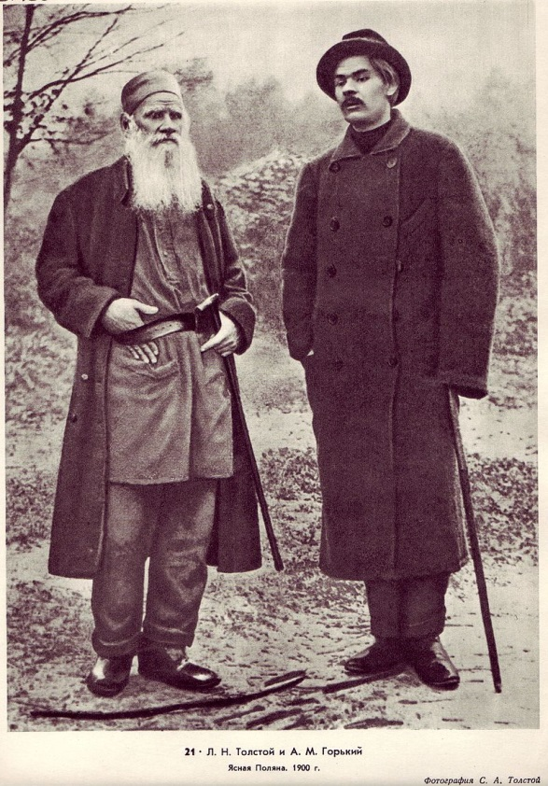 | 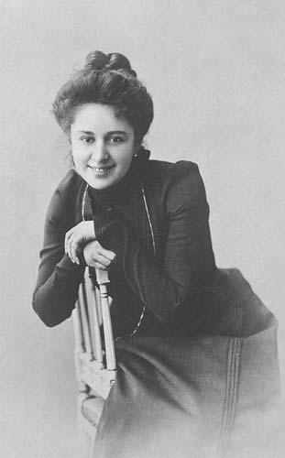
Great writers: Lev Tolstoy and Maxim Gorky in the Tolstoy’s messuage Yasnaya Polyana | Actress of the Moscow Art Theater Andreeva, the civil wife of Maxim Gorky.
Photo: https://ru.wikipedia.org/wiki/%D0%9C%D0%B0%D0%BA%D1%81%D0%B8%D0%BC_%D0%93%D0%BE%D1%80%D1%8C%D0%BA%D0%B8%D0%B9
The Maxim Gorky Museum Flat, Address. Street Semashko, 19. Tel:8 (831) 436-16-51
The State Museum of Maxim Gorky, N.Novgorod Branch, Address street Minina 26. Tel.:+7 (831) 436-15-29
In the USSR period the city of Nizny Novgorod has named after M. Gorky (Gorky city). Here the famous scientist Academician Andrey Sakharov (1921-1989) spent his 7-years exile. The scientist was a developer of the Soviet thermonuclear bomb and later was the Fighter for Civil Rights. While Gorky in Russian language means “Bitter”, and a surname Sakharov means “Sweet”, it was a Soviet joke that next renaming of the city will establish the name “Sweet City” for Nizhny Novgorod. Sakharov was the genius scientist, scientific descendant of another great physicist Academician I. Tamm. Sakharov was one of the three scientists who developed the H-bomb for the USSR. Later understanding the threat of the nuclear weapon for the mankind survival and under influence of his wife Helen Bonner , Sakharov took active part in the International Human Rights Movement. For this activities he was deprived all his state awards and titles, keeping only the “Academician” status in the Academy of Science: the Academy had the secret ballot procedure and his fellows academicians ignored the government pressure: no vote was given to Sakharov’s deprivation. Later Mikhail Gorbachev in his second attempt returned Academician Sakharov from his exile to Moscow in 1986. First attempt was done by another Communist Leader Andropov asking Sakharov to confess in his “ideological mistakes”, but Sakharov refused. Returning in Moscow, as the Soviet Parliament Member, Sakharov continues his human rights activities; many times he was “called to order” by Gorbachev at the Parliament sessions. Sakharov later was named as the “Conscience of the Soviet intellectuals”.
Andrei Sakharov Museum: Address: Prospect Gagarina 214. Tel. +7 (831) 462-61-25
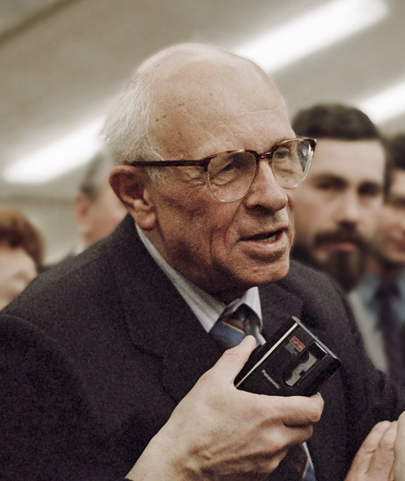
Academician Andrei Sakharov. Photo from the Agency RIAN archive. 1989. RIAN archive 25981 Academician Sakharov.jpg

Another outstanding opposition leader from Nizhny Novgorod was Boris Nemtsov, The Vice-Prime Minister of the Boris Yeltsin Government and later the opposition leader who was killed in Moscow near Kremlin in 2015. He was talented physicist graduated from the Radio-Physics faculty of the Nizhny Novgorod University. Nobel Prize Laureate the Academician Vitaly Ginsburg considered Boris Nemtsov as the outstanding scientist. Boris defended his PHD dissertation and published to his 29 years age more than 60 scientific papers and patents in the area of space radio communications in the “dead zone” when the space apparatus passed the higher atmospheric layers heating to very high temperatures. Under the influence of his mother who was a member of the civil movement against the Gorky Nuclear Electric Power construction, Boris became a politician actor. As a result of the free ballot procedure in the Yeltsin period, Nemtsov won the City Governor elections. As the Nizhny Novgorod Governor he revived the GAZ (Gorky Automobile Plant) which was the city-forming enterprise with maximum jobs for the citizens. The GAZ stated to produce mini-busses “GAZEL” , now the popular mobile auto for the bus-taxi (“marshrutka”) in Russian cities. The GAZ started to make also the vehicles for the Army. Later the West investors came to GAZ with their models: Chevrolet, Volkswagen, and Skoda. Now GAZ is the successful and profitable enterprise. Other Nemtsov’ achievement is the revival of the historical Nizhny Novgorod Fair. The Fair is now the largest Trade Center Complex in the City.
Nizhny Novgorod Fair. Address: street Sovnarkomovskaya, 13
Nemtsov was the closest to the President Boris Yeltsin politician fellow. President Yeltsin called him to Moscow as the Vice-Prime-Minister. In a Crisis 1998, Nemtsov left the government ignoring the calls of Boris Yeltsin to continue work together. Nemtsov took the responsibility for political and economic crisis in Russia-1998 on him alone. Nemtsov actively supported the advancement of Vladimir Putin during his first President term considering him as the forceful leader with distinct program, not linked with oligarchs. Later Boris went to opposition, tried to be elected as the President, proposing his economic development strategy for the country. Nemtsov was against the enforcement of the state control in the economy and finances areas, he called to continue further the liberal market reformations; as politician he was the proponent of the transparent and honest free elections. He was shot and killed crossing the Bolshoy Moskvoretsky Bridge near the Kremlin walls in February 2015. The assassination is still investigated.
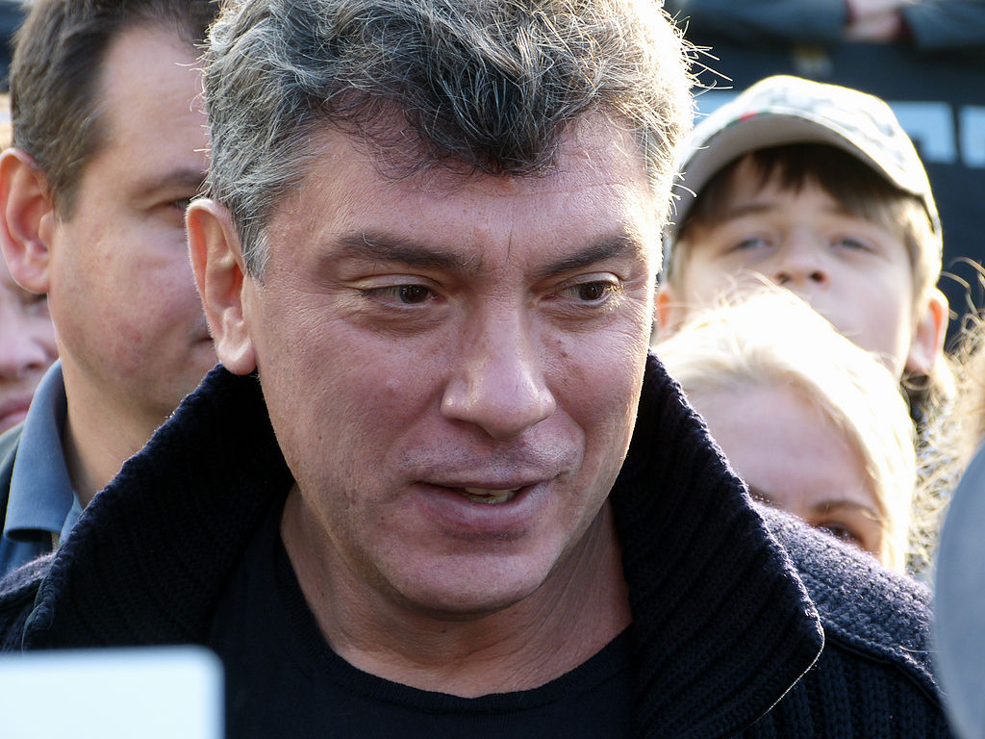
Boris Nemtsov in 2012. Photo: Wikipedia

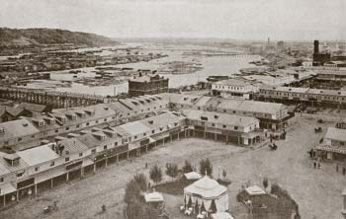 | 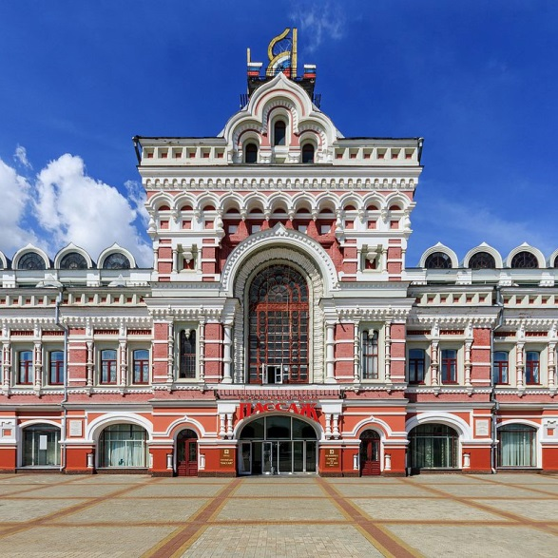
Makaryev Monastery Fair. Historical picture. | Nizhny Novgorod Fair. Recent pavilions.
Photo: https://commons.wikimedia.org/w/index.php?curid=51086202

As a conclusion it may be stated that the old city Nizhny Novgorod as a human community has combined the Russian patriotism, free thinking and the commercial activities. At least once this great city saved Russia from disintegration. Citizens of Nizhny Novgorod are friendly, creative, active and insistent people. Wonderful human features, do you agree?
Essay was compiled using different sources by Alexander Ryss in March of 2017

